**Q1) How do I identify a Breakaway Cable Terminal (BCT)?**

For information on how to identify BCT’s and differentiate them from other types of terminals, See the [Terminal Identification Graphic](http://www.wsdot.wa.gov/publications/fulltext/design/RoadsideSafety/Terminal1.pdf). A BCT is usually parabolic in shape and includes a Type 1 anchor.

**Q2: When does a guardrail run require a crashworthy end terminal?**

Crashworthy end terminals are required on leading ends of guardrail runs that are located within the design clear zone, and on trailing ends of guardrail runs that are within the design clear zone of opposing traffic. Crashworthy terminals can also be installed outside the clear zone if engineering judgement indicates it is warranted.

**Q3: What options do I have when a crashworthy end terminal is to be installed on a curve with a tight radius (such as a loop ramp)?**

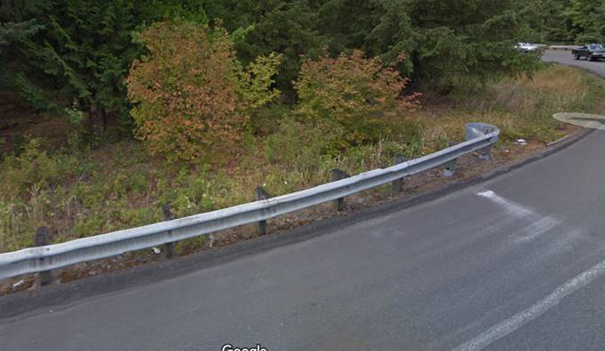

*Loop ramps can be challenging locations to provide end terminals*

Non-flared terminals are not to be installed in a curved alignment, meaning that the rail element is not to be curved. Options for installing non-flared terminals in these locations include:

* Extend the guardrail run until you reach a tangent section of the roadway to locate the terminal.
* For the terminals listed on the Standard Plans, see the manufacturer’s installation instructions for guidance on installing on curves. For instance, the TL-3 SoftStop installation manual gives guidance for installing on curves with radii as small as 650 ft.
* Keep in mind that TL-2 terminals (for use on roadways with posted speeds of 45 mph or less) are shorter, and may be more easily fit into the topography.
* If the guardrail attaches to a bridge rail or concrete barrier, an impact attenuator may be an option where there is not enough room for a transition section and a terminal as long as the length of need requirements can still be met.

**Q4: Can you explain how MASH implementation will affect Type 1 guardrail terminals?**

A pending Standard Specification revision (scheduled for April 2018) will require that all new guardrail terminals be MASH compliant.

Manufacturers have chosen to only provide MASH compliant terminals at a height of 31 inches**.** This means that whenever an existing Type 1 guardrail run requires a new MASH compliant terminal, the Type 31 to Type 1 adaptor [(Standard Plan C-25.80)](http://www.wsdot.wa.gov/publications/fulltext/Standards/english/PDF/c25.80-04_e.pdf) will have to be used to transition the existing 28” high run to the 31” high MASH compliant terminal.

The figure below shows how this applies to the replacement of an existing Breakaway Cable Terminal (BCT).

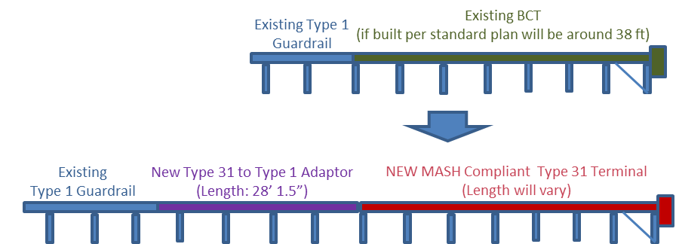

*As shown, installing the Type 31 to Type 1 Adaptor will require either extending the existing guardrail run or removing a section of the existing run in order to install the adaptor.*

For short guardrail runs it may make more sense to remove the entire Type 1 run and install Type 31 guardrail instead.

**Q5: Is it necessary to remove an anchor (or BCT) that is shielded by a barrier?**

In most situations the answer is No. See the examples below.

However, consider whether the terminal is within the design clear zone limits of the opposite direction traffic as noted in Question #2 above.

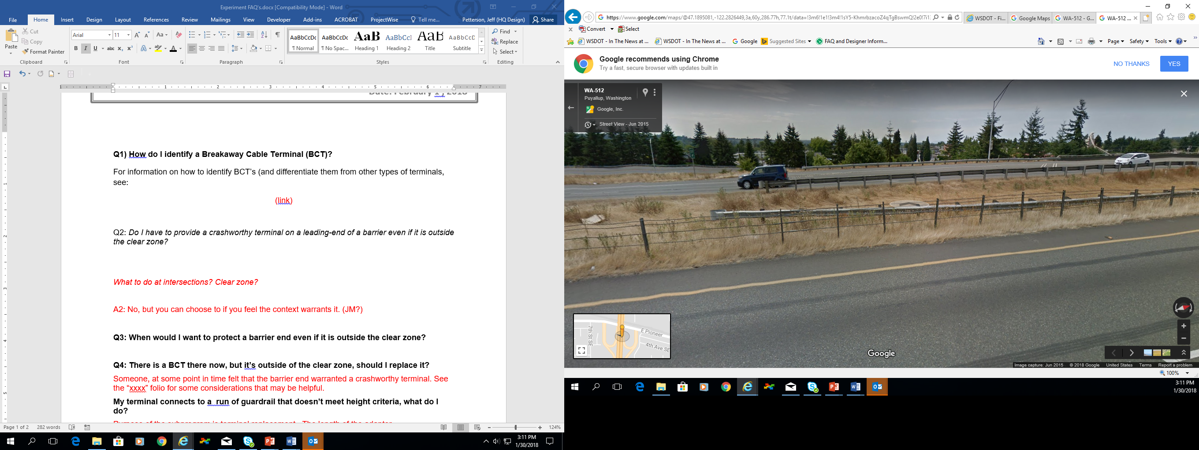 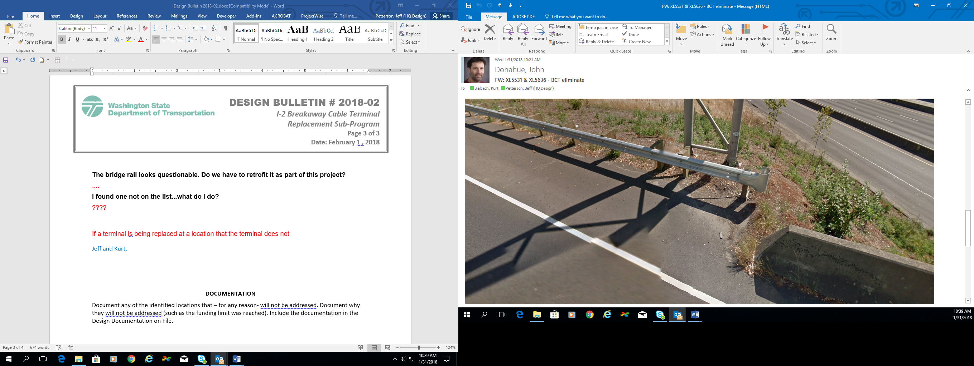

***Example 1:*** *BCT is shielded from oncoming traffic by cable barrier, and BCT is outside the deflection distance of the cable barrier. Also the BCT is shielded from opposing traffic by guardrail. No reason to remove it.*

***Example 2:*** *It is not necessary to remove anchors as long as length of need calculations (Design Manual section 1610.03(5) verify that the anchor and fixed object behind it are shielded by the concrete barrier.*

**Q6: How do I connect w-beam guardrail, thrie beam or transition sections to “low” bridge rail?**

A special connection plate (shown below) designed by the WSDOT Bridge and Structures Office can be used to connect rail elements to a bridge rail that is lower than the rail elements. Contact the Bridge and Structures Office.

 